Word Template Lab Report 2025
(Replace with name of experiment)

Physics 36X Laboratory ###

Date:
TA:
Group number:

Names of everyone in the lab group
One person per line
The University of Calgary


Contents
1. Objective 3
2. Theory 3
3. Experimental Methods 3
4. Data 3
5. Analysis 3
5.1. Math Syntax 4
5.2. Figures 4
6. Discussion 4
7. Conclusion 4
8. References 5

Objective
State the purpose of the experiment and the goals you want to accomplish. Use In 2-3 sentences with strong verbs. Use active voice instead of passive voice (forms of the verb ‘to be’ indicate passive voice):
- We determined ___. Instead of ___ was determined.
- We calculated ___. Instead of ___ was calculated.
- We compared ___. Instead of ___ was compared.
- We investigated ___. Instead of ___ was investigated.

Theory
Include a concise summary of the relevant theory. Cite the equations you use with proper references such as the textbook or laboratory write up you worked from.

Experimental Methods
Describe the steps your group took to conduct the experiment and the needed materials and equipment. Provide sketches and figures of the experimental setup with appropriate captions.

Data
Present your organized data in this section. These data (the word ‘data’ is plural) must match the raw data submitted to D2L before exiting the lab.
Table 1: Caption describing the data contained in the table
Column 1 | Column 2 | Column 3
Data Row 1, Col 1 | Data Row 1, Col 2 | Data Row 1, Col 3
Data Row 2, Col 1 | Data Row 2, Col 2 | Data Row 2, Col 3

Table 2: Caption describing the data contained in the table
 | Measurement | Units
Row 1 measurement | Number | Unit
Row 2 measurement | Number | Unit

You can cut and paste tables made in Excel into Word.

Analysis
Data analysis presents the calculations and thinking about the numerical results of the laboratory work. Display any and all needed calculations, including sample uncertainty calculations. This section frequently has additional tables (comparisons, graphing tables, slope/intercept, etc.), and graphs.

Sub headings in the Data Analysis section help organize thoughts.

Math Syntax
Microsoft Word’s equation editor can be opened by selecting Insert then Equation, then insert new equation. The keyboard shortcut is Alt-N then “E” then “I” for new equation. Math can either be done inline, $a^{5}⋅a^{6}=a^{11}$, or centered,
$$a^{5}⋅a^{6}=a^{11}$$

Figures
A figure can be inserted as follows:

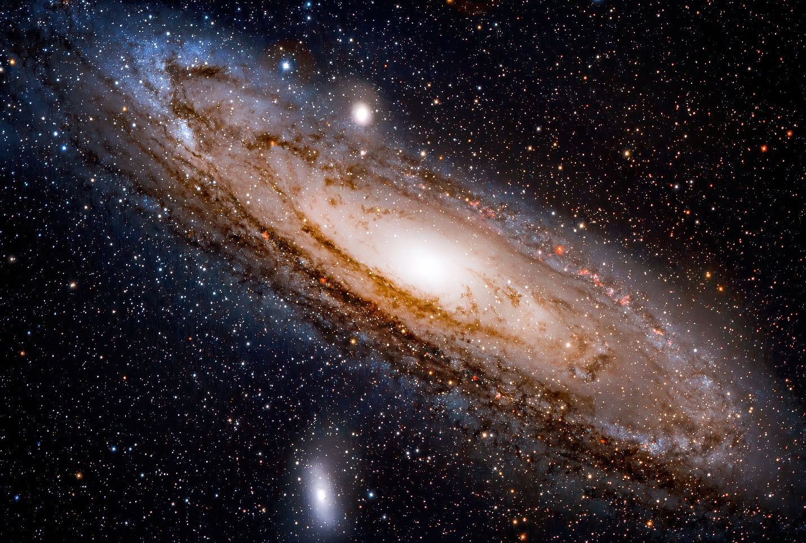
Figure 1: Figure caption describing any symbols and equations on the figure, as well as what is being plotted if it is a plot.
Figure captions appear below figures, but Table captions appear above. I have no idea why.

Discussion
Compare your obtained values to the expected ones using the t-test. Comment on the agreement and possible sources of errors (random and systematic). Make sure that the errors are reasonable given your results.

Conclusion
Report values again and comment on their agreement with accepted values. Provide any concluding thoughts. For this class, this section should be short.

References
References appear on their own separate page. To find details about reference in bibtex refer to this page. Note that different journals have different referencing styles, and as of late many of created bibtex style packages to convey this. The currently chosen style is the basic “plain” style, but if you wish you can go to the AIP website and download their personal .bst style file, for example.

